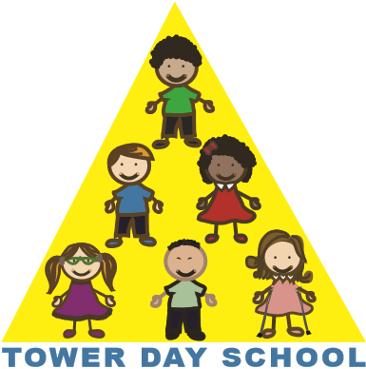

Tower Day School

Application Form

2022/2023

Child’s Name: _______________________________________________________________

Date of Birth: _______/______/__________ Sex: M_______F_______

Parent’s Name: ______________________________________________________________

Home Address: ______________________________________________________________
Street Town Zip

Phone: __________________________email:______________________________________

Name(s) of any sibling(s) who have previously attended Tower Day School:

___________________________________________________________________________

Please number your class choices in order of preference.

Class choice for 3 year-olds

___ T,TH class (8:30 - 11:30)

___ M,W,F class (8:30 - 11:30)

Class choice for 4 year-olds

___ M,W,F class (8:30 - 11:30)

___ M,W,F full day class (8:30 - 2:30)

___ T,W,TH full day class (8:30 - 2:30)

Transition class

___ M,W,F (8:30 - 11:30) and T,TH (8:30 - 2:30)

---------------------------------------------------------------------------------------------------------------------------------------------------------------------------------------------

___ Yes, I have read the attached application information.

Signature____________________________________________Date____________________

Please return this form along with a $75.00 application fee. One per family/non-refundable.
Please make checks payable to: Tower Day School

5 Summer Street, Lynnfield, MA 01940 towerdayschool@gmail.com 781.334.5576 www.towerdayschool.org

